

Subscribe to DeepL Pro to edit this document.  
Visit [www.DeepL.com/pro](https://www.deepl.com/pro?cta=edit-document) for more information.

1. variant

Let the amount of material transported in a single cycle belatexmath kg.

Initial state of chargelatexmath =100%

Let the total mileage belatexmath =10km

Distance between vehicles is d=0.2km

The total number of vehicles is n total = 125.

Speed is v=60km/h

Total number of battery packs per vehicle is n electric 1 = 6 packs

Total number of batteries n electric total = 900 groups

Empty Vehicle SoC Reduction Ratelatexmath =1/3%/min

Cargo Vehicle SoC Reduction Ratelatexmath =1/2%/min

Replacement interval (latexmath ,latexmath )

Replacement of a battery pack takes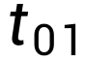 = 20s, charging and detection of each battery pack after replacement takes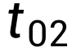 = 3h, loading and unloading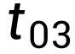 = 1min

Waiting time for the ith vehicle t, etc. i

Battery pack replacement time for the ith vehicle t for i

The position Q of the converter station is at a distance s1 from point P

The position Q of the converter station is at a distance s2 from point D

The average rate of SoC consumption during material transportation by material trucks islatexmath

The time required to travel from point Q of the converter station to point P is

The time required to travel from point Q to point D at a converter station is

Question one:

1. Problem analysis

Let the location of the power exchange is Q, let its distance from point P s1, distance from point D is s2 = s-s1. 1000 hours to start the analysis, because in the figure given a cycle from the power exchange station for the first time to point P is unloaded, from point P to point D is fully loaded, and from point D back to point P on the way through the exchange of the power station Q is unloaded. We note that subsequent intervals in the power exchange regardless of which direction the material truck is transported at the point of exchange (departure), the distance traveled by the material truck in the interval between the two replacements of fully loaded battery packs is an integer multiple of the distance of the material transported over a single route, and the full load time is equal to the empty load time, i.e., the average rate of consumption of the SoC in an interval is a constant value of vc = 5/12%/min. the replacement cycle is limited by the address of the power exchange station and the replacement Requirements limitations The maximum amount of material to be transported in 1000 hours can be calculated for each cycle before considering the total number of cycles. Multiple material trucks can be transported at the same time, and the number of their dispatches and departure times are obviously related to the distance limitation. At the same time, due to the different locations of the power station, the replacement cycle is different, so the battery pack surplus of the power station at the same time is also different, and the program should ensure that each time the next material truck comes by the battery pack surplus can be replaced, so corresponding to the different scheduling programs

III. Model assumptions

1. There is no other vehicle on the dedicated lane, i.e., the material trucks are traveling in full compliance with the set rate.

2. Not taking into account the time spent by material trucks turning around

3. Start timing from the first material truck

4. Since it takes only 20 minutes to complete a cycle of transportation of materials (including loading and unloading), it may be advisable to regard the material trucks that have not completed a cycle of transportation of materials within 1,000 hours as having completed a cycle of transportation.

5. Since a cycle of transportation consumes less electricity and the distance is shorter, the time spent going to points P and D is not much different, so it can be approximated that the running course and time spent by the material trucks are the same in each replacement cycle.

6. Taking continuity variables

7. Ignore the time difference between the start of charging and the detection of entering the standby state after replacing the battery pack for the same vehicle each time

IV. Modeling

Let the time of a replacement cycle be T, T=t1+t2+t3, where t2 denotes the time taken by the material truck to go back and forth between points P and D, t3 denotes the time required for loading and unloading of the material truck, and t1 denotes the time required for the material truck to change the electricity.

t2=2ytd+2xtp,

tp is the time taken to travel from the exchange station to point P, the

tp=s1/v

td is the travel time from the exchange station to point D

td=s2/v

x, y denote the number of round trips of the material truck between points Q and P, and the number of round trips of the material truck between points Q and D, respectively; x, y are integers, 1 => x - y >= 0

latexmathThe time corresponds to the case when the material truck completes an integer number of round trips from the power exchange station and then performs a changeover,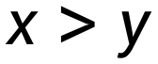 (LaTeX programming) corresponds to the case when the material truck completes an integer number of round trips and travels to either point P or D once and then returns; it is approximated that the travel conditions and time spent for each changeover are the same according to Assumption 5.

accessible

Decision variables:

The distance of point Q from point P, s1,x,y, denote the number of round trips of the material truck between point Q and point P, and the number of round trips of the material truck between point Q and point D, respectively.

Objective function:

is the minimum of t-exchange/t-operation in a switching cycle, and the

t3=(x+y)*t03, t1=6t01

t2=2y*td+2x*tp

assume (office) 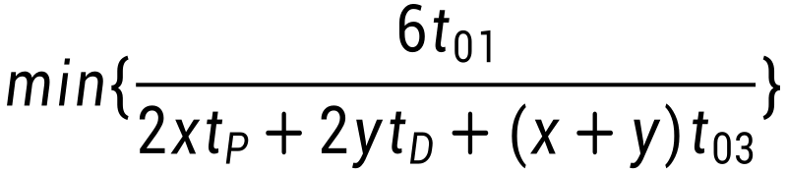

Again, since the numerator is fixed, it is only useful to consider, and it may be useful to use the number of cars as weights



assume (office)

Constraints:

The car's power constraints:

10%=<e0-vct2<=25%

Constraints can also be added in order to maximize the duration:

x>y indicates that the direction of travel of the material truck is to point D when the power is switched.

Then e0-vct2-2vctd < 10% is required

x=y means that the direction of travel of the material vehicle is to point P at the time of power exchange

would require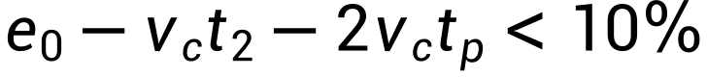

Integer constraints on x and y:

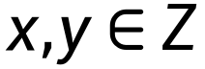

latexmath

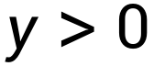

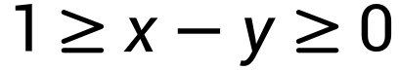

For computational convenience, the original model is split into two separate optimal solutions

Model I, x=y:

assume (office) 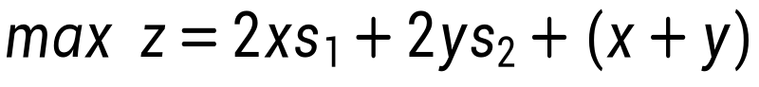

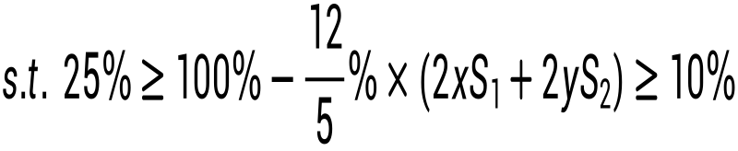

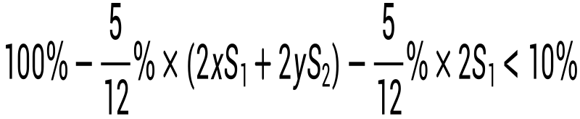

latexmath

latexmath



Substitute LINGO to solve

coding

model.

max=2*x*S1+2*y*S2+x+y;

[time] 12-0.05*(2*x*S1+2*y*S2)>=1.2;

[time3] 12-0.05*(2*x*S1+2*y*S2)<=3;

[time2] 12-0.05*(2*x*S1+2*y*S2)-0.05*2*S1<1.2;

[zeng]x=y.

[he]S1+S2=10.

@gin(x).

@gin(y).

end

Local optimal solution found.

Objective value: 220.0000

Objective bound: 220.0000

Infeasibilities: 0.000000

Extended solver steps: 3

Total solver iterations: 71

Elapsed runtime seconds: 0.66

Model Class: MIQP

Total variables: 4

Nonlinear variables: 4

Integer variables: 2

Total constraints: 6

Nonlinear constraints: 4

Total nonzeros: 20

Nonlinear nonzeros: 8

Variable Value Reduced Cost

X 10.00000 -22.00000

S1 8.623991 0.000000

Y 10.00000 0.000000

S2 1.376009 0.000000

Row Slack or Surplus Dual Price

1 220.0000 1.000000

TIME 0.8000000 0.000000

TIME3 1.000000 0.000000

TIME2 0.6239909E-01 0.000000

ZENG 0.000000 -3.752038

HE 0.000000 20.00000

Global optimal solution found.

Objective value: 220.0000

Objective bound: 220.0000

Infeasibilities: 0.000000

Extended solver steps: 3

Total solver iterations: 192

Elapsed runtime seconds: 0.40

Model Class: MIQP

Total variables: 4

Nonlinear variables: 4

Integer variables: 2

Total constraints: 6

Nonlinear constraints: 4

Total nonzeros: 20

Nonlinear nonzeros: 8

Variable Value Reduced Cost

X 10.00000 -22.00000

S1 10.00000 0.000000

Y 10.00000 0.000000

S2 0.000000 0.000000

Row Slack or Surplus Dual Price

1 220.0000 1.000000

TIME 0.8000000 0.000000

TIME3 1.000000 0.000000

TIME2 0.2000000 0.000000

ZENG 0.000000 -1.000000

HE 0.000000 20.00000

Model 2: x=y+1

model.

max=2*x*S1+2*y*S2+x+y;

[time] 12-0.05*(2*x*S1+2*y*S2)>=1.2;

[time3] 12-0.05*(2*x*S1+2*y*S2)<=3;

[time2] 12-0.05*(2*x*S1+2*y*S2)-0.05*2*S2<1.2;

[zeng]x=y+1;

[he]S1+S2=10.

@gin(x).

@gin(y).

End

Global optimal solution found.

Objective value: 237.0000

Objective bound: 237.0000

Infeasibilities: 0.000000

Extended solver steps: 3

Total solver iterations: 222

Elapsed runtime seconds: 0.52

Model Class: MIQP

Total variables: 4

Nonlinear variables: 4

Integer variables: 2

Total constraints: 6

Nonlinear constraints: 4

Total nonzeros: 20

Nonlinear nonzeros: 8

Variable Value Reduced Cost

X 11.00000 -2.000000

S1 8.000000 0.000000

Y 10.00000 0.000000

S2 2.000000 0.000000

Row Slack or Surplus Dual Price

1 237.0000 1.000000

TIME 0.000000 -20.00000

TIME3 1.800000 0.000000

TIME2 0.2000000 0.000000

ZENG 0.000000 -1.000000

HE 0.000000 0.000000

It can be seen that the optimal case should be to build the station 8km away from point P, using scheme II, and with 11 round trips between point Q and point P, and 10 round trips between point Q and point D. The total running time plus unloading time is 23 minutes. At this point, the total running plus unloading time is 237 minutes, at which time the car just SoC is 10% when the power change is performed. It is easy to get that the time of 220min for option 1 is achievable in any case, therefore, the choice of option 2 does not affect its choice of option 1, and it can definitely take less time than option 1 after the commutation without option 1, which is a better choice. If the first trip is reversed, the running time when the second trip is optimally selected is 225 min. therefore, the two switching cycles of the material truck are 237 min and 225 min, i.e., 239 min and 227 min, and it is necessary to change 60,000/466*2=256 times the electricity in two consecutive cycles, in addition to the fact that it can be run for 352 min, i.e., 16 trips in addition to its own changed The electricity can wait for charging in addition to the need to use the power exchange station electricity . Because the time needed for charging is less than the cycle time, so the material car can completely use their own replaced electricity, so you can first send out 100 cars, but only 25 of them to change the electricity, and then sent to stay in the power station of the 25 cars to go, due to the address of the power station design, the 100th car to go to the other side of the road for the change of electricity through the D->P direction of the power station, when staying in the car at the power station of the can be in accordance with the smallest distance between cars. The other 75 cars can follow the minimum distance between them when they pass the D->P power exchange station before the first 25 cars make the second power exchange. The other 75 cars can follow at the minimum distance when the first 25 cars pass through the station before the second power change. The finalThe first 25 cars traveled without interruption, approximating that the first cycle did not keep up with the first 25 cars smart next cycle to continue, while the remaining 75 cars had a cycle of (239+228) min a trip. There are still 25 cars on the road in between the charging of the 75 cars. Thus it can be approximated that the other 100 cars run half as many trips as these 25 cars.

So:

The total volume of transportation is (128*21+16)*25+100*(128*21+16)*1/2=202,800 trips

Issue 2

Decision variables: Let the locations of the two power stations M and N from point P be S3 and S4, and the number of round trips z, w along M-P-N and N-D-M, respectively.

Resetting the variables, let the M permutation station be in the direction of point D toward point P, while the N permutation station is in the direction of point P toward point D. Let the time spent along the M-P-N path be t3 and the time spent along N-D-M be t4, then you can write the expressions for t3 and t4, viz:

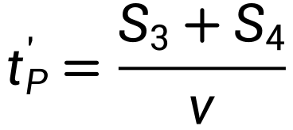

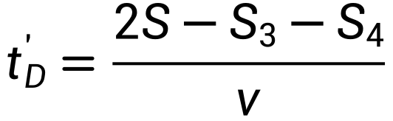

Similar to Problem 1, there are also two cases z>w and z=w

Objective function:

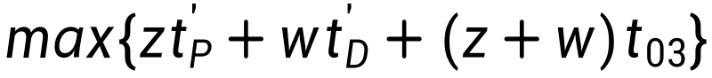

Constraints: also the power constraint and the non-negative integer constraints on z and w. For ease of solution, the original model is also split here into two

Program I:

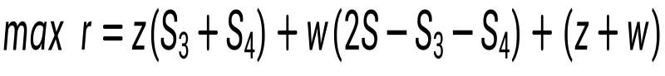

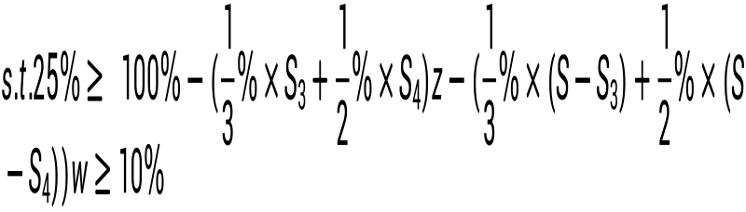

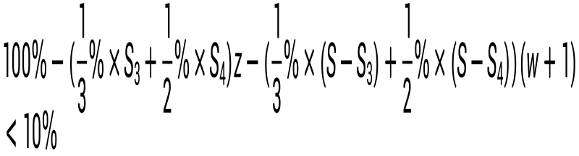

latexmath

latexmath

latexmath

Solving with LINGO

model.

max=z*(S3+S4)+w*(20-S3-S4)+z+w;

[elec]1.5>=6-(0.02*S3+0.03*S4)*z-(0.02*(10-S3)+0.03*(10-S4))*w;

[elec1]6-(0.02*S3+0.03*S4)*z-(0.02*(10-S3)+0.03*(10-S4))*w>=0.6;

[elec2]6-(0.02*S3+0.03*S4)*z-(0.02*(10-S3)+0.03*(10-S4))*(w+1)<0.6;

[num2]S3<10.

[num3]S4<10.

[num] z=w+1;

@gin(z).

@gin(w).

Global optimal solution found.

Objective value: 237.6667

Objective bound: 237.6667

Infeasibilities: 0.000000

Extended solver steps: 3

Total solver iterations: 401

Elapsed runtime seconds: 0.38

Model Class: MIQP

Total variables: 4

Nonlinear variables: 4

Integer variables: 2

Total constraints: 7

Nonlinear constraints: 4

Total nonzeros: 20

Nonlinear nonzeros: 16

Variable Value Reduced Cost

Z 11.00000 -5.333333

S3 10.00000 -0.3333333

S4 6.666667 0.000000

W 10.00000 0.000000

Row Slack or Surplus Dual Price

1 237.6667 1.000000

ELEC 0.9000000 0.000000

ELEC1 0.000000 -33.33333

ELEC2 0.1000000 0.000000

NUM2 0.000000 0.000000

NUM3 3.333333 0.000000

NUM 0.000000 -1.000000

Program II:

model.

max=z*(S3+S4)+w*(20-S3-S4)+z+w;

[elec]1.5>=6-(0.02*S3+0.03*S4)*z-(0.02*(10-S3)+0.03*(10-S4))*w;

[elec1]6-(0.02*S3+0.03*S4)*z-(0.02*(10-S3)+0.03*(10-S4))*w>=0.6;

[elec2]6-(0.02*S3+0.03*S4)*(z+1)-(0.02*(10-S3)+0.03*(10-S4))*w<0.6;

[num2]S3<10.

[num3]S4<10.

[num] z=w.

@gin(z).

@gin(w).

Global optimal solution found.

Objective value: 220.0000

Objective bound: 220.0000

Infeasibilities: 0.000000

Extended solver steps: 3

Total solver iterations: 260

Elapsed runtime seconds: 0.41

Model Class: MIQP

Total variables: 4

Nonlinear variables: 4

Integer variables: 2

Total constraints: 7

Nonlinear constraints: 4

Total nonzeros: 20

Nonlinear nonzeros: 16

Variable Value Reduced Cost

Z 10.00000 -22.00000

S3 5.000000 0.000000

S4 10.00000 0.000000

W 10.00000 0.000000

Row Slack or Surplus Dual Price

1 220.0000 1.000000

ELEC 0.5000000 0.000000

ELEC1 0.4000000 0.000000

ELEC2 0.000000 0.000000

NUM2 5.000000 0.000000

NUM3 0.000000 0.000000

NUM 0.000000 -6.000000

Therefore, the corresponding sites for the switching stations in Option 1 should be selected, i.e., one switching station is located at point D going to point P; the other is located at the one-third split point on the lane close to point P at .

model analysis

Therefore, Problem 2 is similar to Problem 1, the optimal choice of the first trip determines the shortest time consumption of thereafter, and is the optimal siting, the length of the first cycle is 237.667min, that is, the material truck runs 10 trips to change power at the power station N; and the optimal choice of the next cycle is calculated to be the length of the cycle of the material truck running 10 trips to change power at the power station M is 224.33min. Therefore the total cycle length is 462 min, which is similar to the problem 1 case , i.e.:

The total volume of transportation is (128*21+16)*25+100*(128*21+16)*1/2=202,800 trips

It was found that installing off-site switching stations did not significantly improve transportation efficiency.